MODULE 1 — AUTOMATION WITH SELENIUM

EXPERIMENT 1.1 — Introduction and Different Flavors of Selenium

1. Module Name and Experiment Title
Module: Automation with Selenium
Experiment: Introduction and Different Flavors of Selenium

2. Problem Statement
To study Selenium automation and understand the different Selenium components used for automating web applications.

3. Objective
To understand the purpose of Selenium and learn the basic differences between Selenium IDE, Selenium RC, Selenium WebDriver, and Selenium Grid.

4. Tools, Software and Concepts Used
- Python 3
- Selenium 4
- Google Chrome / Microsoft Edge
- VS Code
- Selenium IDE
- Selenium WebDriver
- Selenium Grid
- Browser automation

5. Source Code / Implementation Steps
For basic WebDriver demonstration:
from selenium import webdriver

driver = webdriver.Chrome()

driver.get("https://www.example.com")

print("Title:", driver.title)
print("URL:", driver.current_url)

driver.quit()
Steps:
- Open VS Code.
- Create a Python file named experiment_1_1.py.
- Install Selenium:
pip install selenium
- Write the above code.
- Run the program.
- Observe that Chrome opens.
- The browser opens example.com.
- The title and URL are displayed in the terminal.
- Browser closes automatically.

6. Output with Clearly Labelled Screenshots
Screenshot 1:
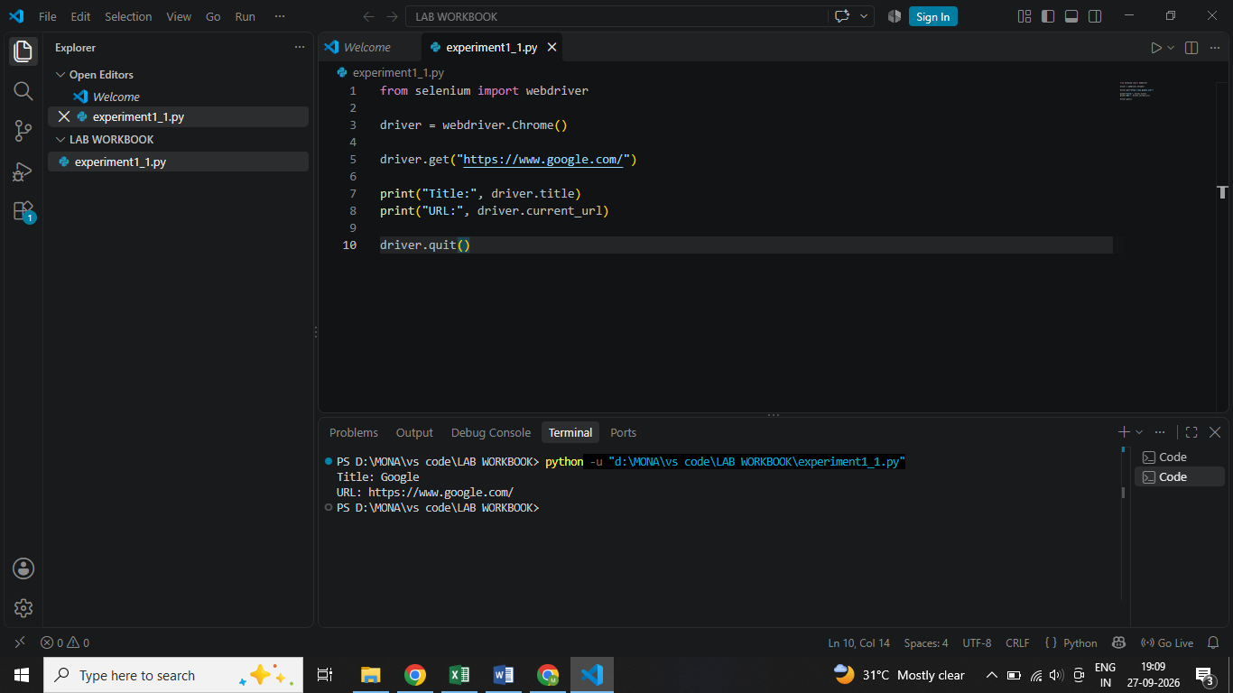
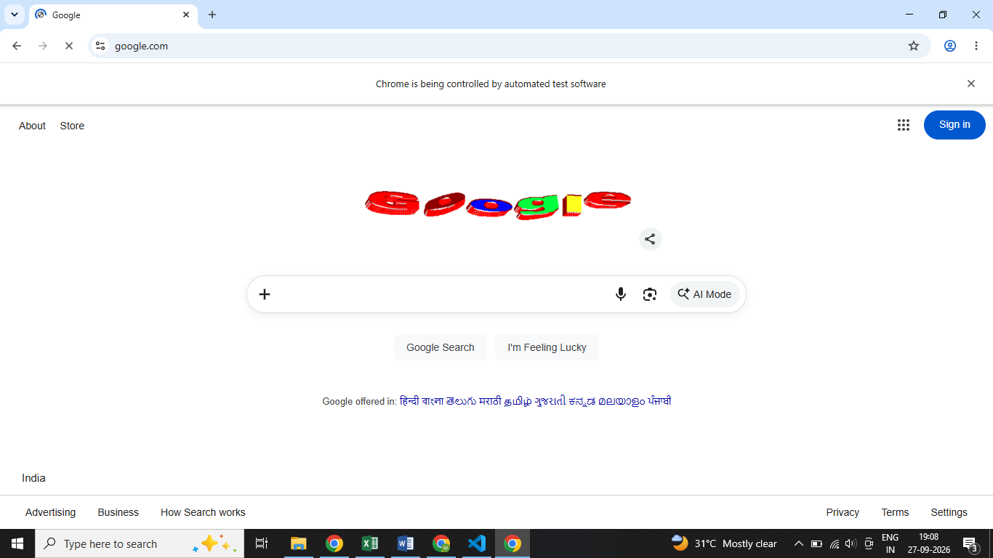
Screenshot 2:

7. Result, Observation and Conclusion
Result: Selenium WebDriver successfully opened and controlled the browser.
Observation: Selenium provides different tools for web automation. WebDriver is used for programmatic browser automation, IDE provides record/playback functionality, and Grid supports execution across different environments.
Conclusion: Selenium is useful for automating and testing web applications.

EXPERIMENT 1.2 — Selenium WebDriver Introduction and Installation

1. Module Name and Experiment Title
Module: Automation with Selenium
Experiment: Selenium WebDriver Introduction and Installation

2. Problem Statement
To install Selenium WebDriver with Python and configure the environment for executing automated browser tests.

3. Objective
To understand Selenium WebDriver architecture, install Selenium, configure the browser environment, and execute a simple test on different browsers.

4. Tools, Software and Concepts Used
- Python 3
- VS Code
- Selenium 4
- Chrome
- Microsoft Edge
- Firefox
- pip
- Selenium WebDriver
- Selenium Manager

5. Source Code / Implementation Steps
Install Selenium:
pip install selenium
Check installation:
pip show selenium
Basic Chrome test:
from selenium import webdriver

driver = webdriver.Chrome()

driver.get("https://www.example.com")

print(driver.title)

driver.quit()
For Edge:
from selenium import webdriver

driver = webdriver.Edge()

driver.get("https://www.example.com")

print(driver.title)

driver.quit()
For Firefox:
from selenium import webdriver

driver = webdriver.Firefox()

driver.get("https://www.example.com")

print(driver.title)

driver.quit()
Steps:
- Install Python.
- Install VS Code.
- Open VS Code terminal.
- Install Selenium using pip.
- Verify Selenium installation.
- Create a Python file.
- Create WebDriver object.
- Open a website.
- Print the title.
- Close the browser using quit().
- Repeat using Edge and Firefox.

6. Output with Clearly Labelled Screenshots
Screenshot 1:
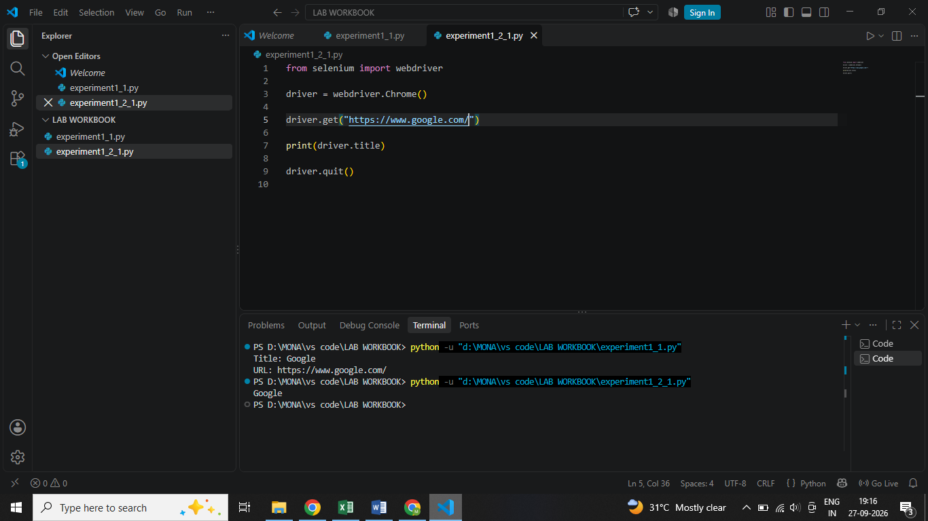
Screenshot 2:
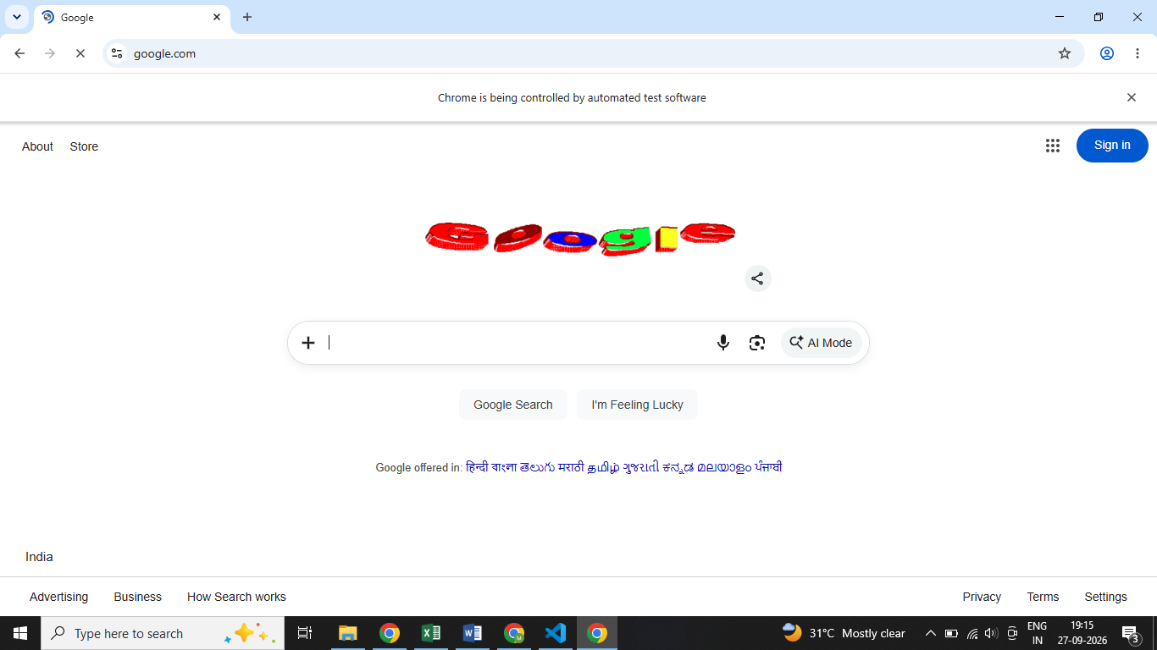.
Screenshot 3:
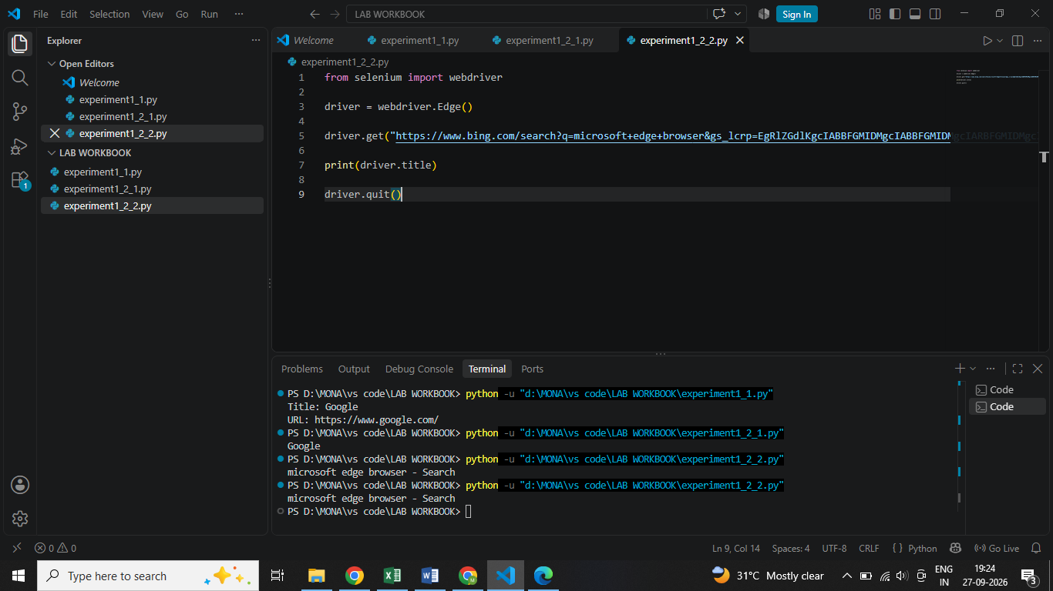
Screenshot 4:

7. Result, Observation and Conclusion
Result: Selenium WebDriver was successfully installed and executed.
Observation: Selenium 4 can automatically manage the required browser driver in many normal setups using Selenium Manager.
Conclusion: The Python environment is ready for Selenium automation and the same test can be executed on different browsers.

EXPERIMENT 1.3 — Locators and Object Identification

1. Module Name and Experiment Title
Module: Automation with Selenium
Experiment: Locators and Object Identification

2. Problem Statement
To identify web elements on a webpage using different Selenium locator strategies.

3. Objective
To learn how to inspect HTML elements and select appropriate locators for browser automation.

4. Tools, Software and Concepts Used
- Python
- Selenium WebDriver
- Chrome DevTools
- By.ID
- By.NAME
- By.TAG_NAME
- By.LINK_TEXT
- By.CLASS_NAME
- By.CSS_SELECTOR
- find_element()
- find_elements()

5. Source Code / Implementation Steps
Example:
from selenium import webdriver
from selenium.webdriver.common.by import By

driver = webdriver.Chrome()

driver.get("https://the-internet.herokuapp.com/login")

username = driver.find_element(By.ID, "username")
password = driver.find_element(By.NAME, "password")

username.send_keys("tomsmith")
password.send_keys("SuperSecretPassword!")

print("Username:", username.get_attribute("value"))

driver.quit()
For multiple elements:
links = driver.find_elements(By.TAG_NAME, "a")

print("Number of links:", len(links))

for link in links:
print(link.text)
Steps:
- Open the webpage.
- Press F12 to open Developer Tools.
- Inspect the required element.
- Identify ID, name, class or tag.
- Create the locator.
- Use find_element().
- For multiple matching elements use find_elements().
- Test the locator.
- Verify the output.

6. Output with Clearly Labelled Screenshots
Screenshot 1:
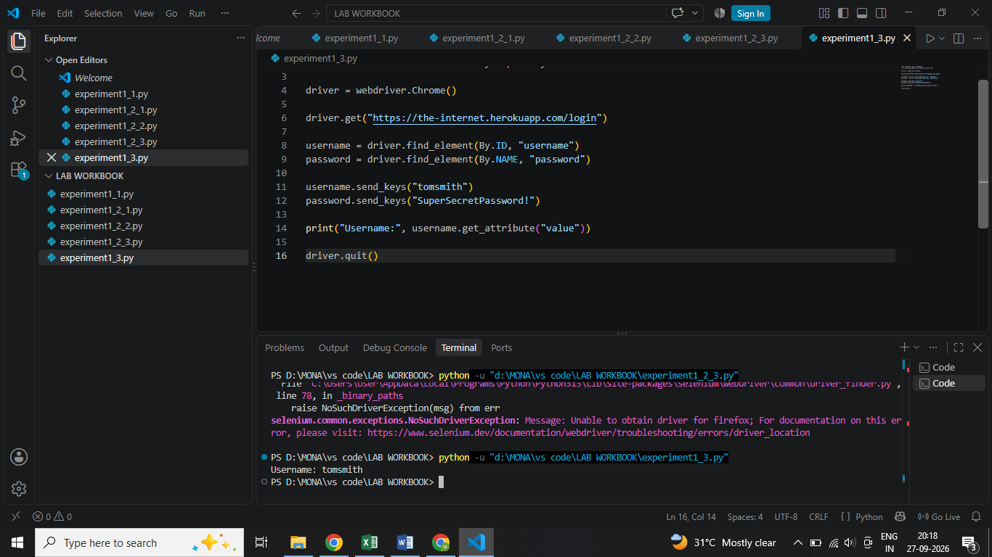
Screenshot 2:
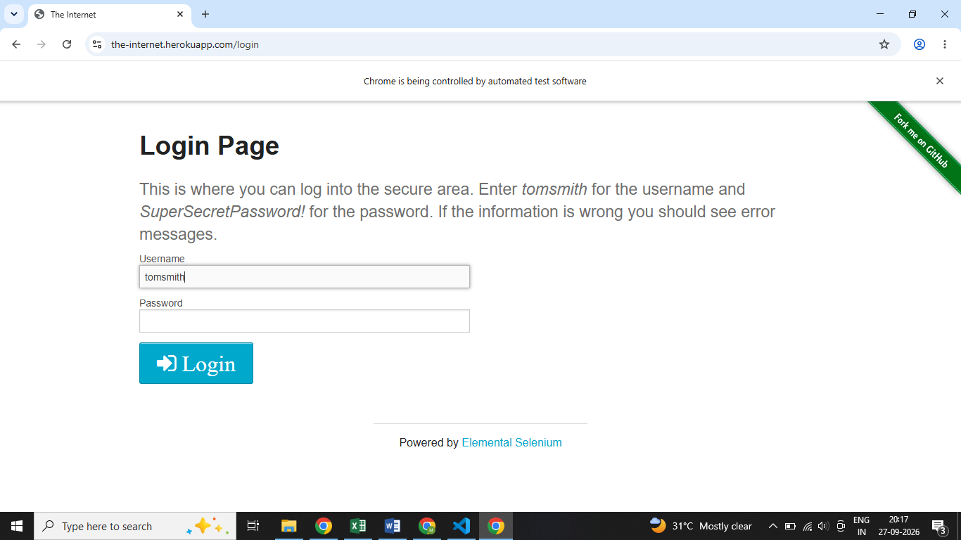

7. Result, Observation and Conclusion
Result: Web elements were successfully identified using Selenium locators.
Observation: Different locator strategies are useful depending on the HTML structure.
Conclusion: Proper locator identification is an important part of Selenium automation.

EXPERIMENT 1.4 — Handling Different Controls on Web Page

1. Module Name and Experiment Title
Module: Automation with Selenium
Experiment: Handling Different Controls on Web Page

2. Problem Statement
To automate different types of controls available on a web page using Selenium.

3. Objective
To learn how to locate and interact with buttons, text fields, checkboxes, radio buttons and dropdowns.

4. Tools, Software and Concepts Used
- Python
- Selenium WebDriver
- XPath
- CSS Selector
- click()
- send_keys()
- clear()
- is_selected()
- Select

5. Source Code / Implementation Steps
Button:
button = driver.find_element(By.XPATH, "//button")
button.click()
Input box:
textbox = driver.find_element(By.ID, "username")
textbox.send_keys("Monalisa")
textbox.clear()
Checkbox:
checkbox = driver.find_element(
By.CSS_SELECTOR, "input[type='checkbox']"
)

if not checkbox.is_selected():
checkbox.click()
Select box:
from selenium.webdriver.support.ui import Select

dropdown = Select(
driver.find_element(By.ID, "dropdown")
)

dropdown.select_by_visible_text("Option 1")
Steps:
- Open the required webpage.
- Inspect the element.
- Create the locator.
- Perform the required action.
- Verify the result.
- For XPath, practice absolute and relative XPath.
- Practice contains() and starts-with().
- Practice parent/sibling relationships.
- Handle each control separately.

6. Output with Clearly Labelled Screenshots
Screenshot 1:
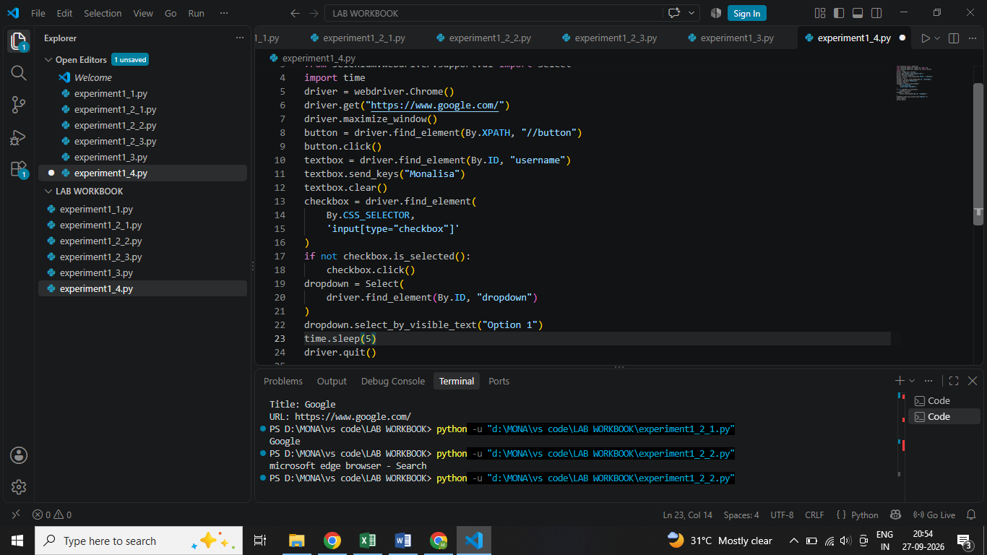

7. Result, Observation and Conclusion
Result: Different webpage controls were successfully automated.
Observation: Selenium provides different methods for interacting with different HTML controls.
Conclusion: Understanding locators and element-specific methods is essential for successful web automation.

EXPERIMENT 1.5 — Handling Different Controls on Web Page – Advanced

1. Module Name and Experiment Title
Module: Automation with Selenium
Experiment: Advanced Handling of Web Controls

2. Problem Statement
To automate advanced web controls and browser interactions using Selenium WebDriver.

3. Objective
To learn how to handle alerts, windows, files, frames, keyboard/mouse operations and dynamic element states.

4. Tools, Software and Concepts Used
- Python
- Selenium WebDriver
- Alert
- ActionChains
- Keys
- switch_to.frame()
- window_handles
- execute_script()
- is_enabled()
- .text
- get_attribute()

5. Source Code / Implementation Steps
Alert:
driver.find_element(By.XPATH, "//button").click()

alert = driver.switch_to.alert

print(alert.text)

alert.accept()
File Upload:
file = driver.find_element(By.ID, "file-upload")

file.send_keys(r"C:\Users\YourName\Desktop\sample.txt")
Multiple Windows:
original = driver.current_window_handle

driver.find_element(By.LINK_TEXT, "Click Here").click()

for handle in driver.window_handles:
if handle != original:
driver.switch_to.window(handle)
print(driver.title)
Keyboard:
from selenium.webdriver.common.keys import Keys

textbox.send_keys("Hello")
textbox.send_keys(Keys.ENTER)
Mouse hover:
from selenium.webdriver.common.action_chains import ActionChains

ActionChains(driver).move_to_element(element).perform()
Iframe:
driver.switch_to.frame("frame_name")

# interact with frame

driver.switch_to.default_content()
JavaScript scrolling:
driver.execute_script(
"window.scrollTo(0, document.body.scrollHeight);"
)

7. Result, Observation and Conclusion
Result: Advanced web controls were successfully handled using Selenium.
Observation: Selenium provides specialized classes and methods for different browser interactions.
Conclusion: Advanced Selenium commands allow automation of complex real-world web applications.

EXPERIMENT 1.6 — Handling Dynamic Elements

1. Module Name and Experiment Title
Module: Automation with Selenium
Experiment: Handling Dynamic Elements and WebTables

2. Problem Statement
To locate and process dynamically generated table data using Selenium.

3. Objective
To identify rows and columns of a web table and retrieve required information.

4. Tools, Software and Concepts Used
- Python
- Selenium WebDriver
- HTML Table
- find_elements()
- XPath
- Python loops

5. Source Code / Implementation Steps
from selenium import webdriver
from selenium.webdriver.common.by import By

driver = webdriver.Chrome()

driver.get("https://the-internet.herokuapp.com/tables")

table = driver.find_element(By.ID, "table1")

rows = table.find_elements(By.TAG_NAME, "tr")

print("Number of rows:", len(rows))

for row in rows:
cells = row.find_elements(By.TAG_NAME, "td")

for cell in cells:
print(cell.text)

driver.quit()
Steps:
- Open the web table.
- Locate the table.
- Locate table rows.
- Locate cells inside each row.
- Traverse each row.
- Read cell values.
- Print the required information.
- Search for a particular value if required.

7. Result, Observation and Conclusion
Result: The web table was successfully located and traversed.
Observation: Nested find_elements() can be used to process rows and cells.
Conclusion: Selenium can retrieve and process structured data from dynamic web tables.

EXPERIMENT 1.7 — Synchronization / Wait Type

1. Module Name and Experiment Title
Module: Automation with Selenium
Experiment: Synchronization and Wait Types
Topics covered:
- Why synchronization?
- Implicit wait
- Explicit wait

2. Problem Statement
To synchronize Selenium execution with dynamic webpage loading.

3. Objective
To understand why waits are required and implement implicit and explicit waits.

4. Tools, Software and Concepts Used
- Python
- Selenium WebDriver
- Implicit Wait
- Explicit Wait
- WebDriverWait
- Expected Conditions

5. Source Code / Implementation Steps
Implicit Wait:
driver.implicitly_wait(10)
Explicit Wait:
from selenium.webdriver.support.ui import WebDriverWait
from selenium.webdriver.support import expected_conditions as EC

element = WebDriverWait(driver, 10).until(
EC.element_to_be_clickable(
(By.ID, "username")
)
)
Steps:
- Open a dynamic webpage.
- Identify an element that takes time to become available.
- Apply implicit wait.
- Run the test.
- Apply explicit wait.
- Wait for a specific condition.
- Interact with the element.
- Verify successful execution.
.

6. Result, Observation and Conclusion
Result: Selenium successfully waited for the required webpage elements.
Observation: Explicit waits are useful when a particular condition must be satisfied before continuing.
Conclusion: Proper synchronization makes Selenium tests more reliable.

EXPERIMENT 1.8 — Take Screenshots and Exception Handling

1. Module Name and Experiment Title
Module: Automation with Selenium
Experiment: Screenshots and Exception Handling
Topics covered:
- Taking screenshots
- Generic screenshot method
- Exception handling
- try
- except
- finally

2. Problem Statement
To capture browser screenshots and handle runtime Selenium exceptions safely.

3. Objective
To learn how to take screenshots during test execution and use Python exception handling to prevent unexpected test termination.

4. Tools, Software and Concepts Used
- Python
- Selenium
- save_screenshot()
- try
- except
- finally
- Selenium exceptions

5. Source Code / Implementation Steps
Screenshot:
from selenium import webdriver

driver = webdriver.Chrome()

driver.get("https://www.example.com")

driver.save_screenshot("homepage.png")

driver.quit()
Generic screenshot method:
def take_screenshot(driver, filename):
driver.save_screenshot(filename)
Exception handling:
from selenium import webdriver
from selenium.webdriver.common.by import By
from selenium.common.exceptions import NoSuchElementException

driver = webdriver.Chrome()

try:
driver.get("https://www.example.com")

element = driver.find_element(
By.ID, "wrong_element"
)

except NoSuchElementException:
print("Element not found.")

finally:
driver.quit()
print("Browser closed.")

6. Output with Clearly Labelled Screenshots
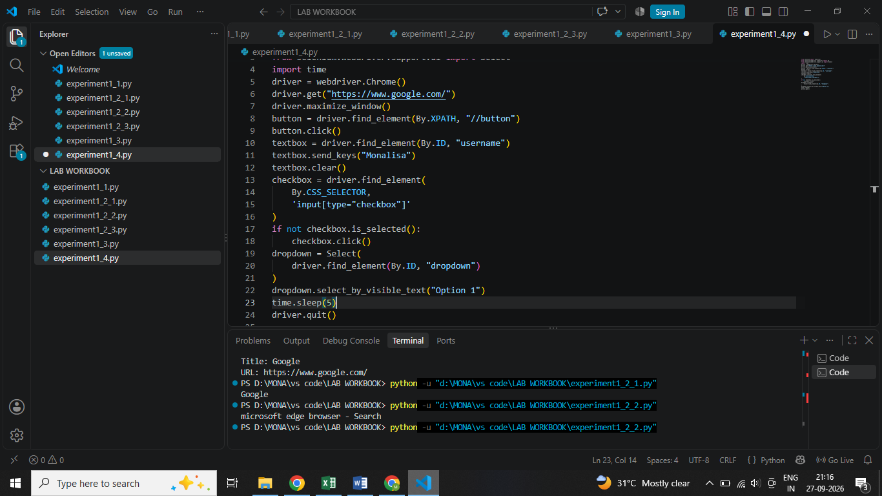.

7. Result, Observation and Conclusion
Result: Screenshot capture and exception handling were successfully implemented.
Observation: try-except-finally helps manage errors and ensures cleanup.
Conclusion: Screenshots and exception handling are important for debugging and maintaining Selenium test scripts.

EXPERIMENT 1.9 — Advance Interactions

1. Module Name and Experiment Title
Module: Automation with Selenium
Experiment: Advanced Data and Browser Interactions

2. Problem Statement
To use external test data and perform advanced browser interactions in Selenium automation.

3. Objective
To learn data-driven automation and advanced mouse/browser operations.

4. Tools, Software and Concepts Used
- Python
- Selenium
- openpyxl
- json
- csv
- configparser
- xml.etree.ElementTree
- ActionChains
- JavaScript
- execute_script()

5. Source Code / Implementation Steps
Reading Excel:
from openpyxl import load_workbook

workbook = load_workbook("testdata.xlsx")

sheet = workbook.active

print(sheet["A1"].value)
print(sheet["B1"].value)
Reading JSON:
import json

with open("testdata.json", "r") as file:
data = json.load(file)

print(data)
Writing JSON:
import json

data = {
"test": "Login Test",
"status": "PASS"
}

with open("result.json", "w") as file:
json.dump(data, file, indent=4)
Mouse hover:
from selenium.webdriver.common.action_chains import ActionChains

ActionChains(driver).move_to_element(element).perform()
JavaScript:
driver.execute_script(
"window.scrollTo(0, document.body.scrollHeight);"
)

6. Result, Observation and Conclusion
Result: External test data was successfully read/written and advanced browser interactions were performed.
Observation: Separating test data from automation code makes test scripts easier to maintain.
Conclusion: Selenium can be integrated with external data sources and JavaScript/mouse interactions for advanced automation.

